I233018
LAB10

q1:

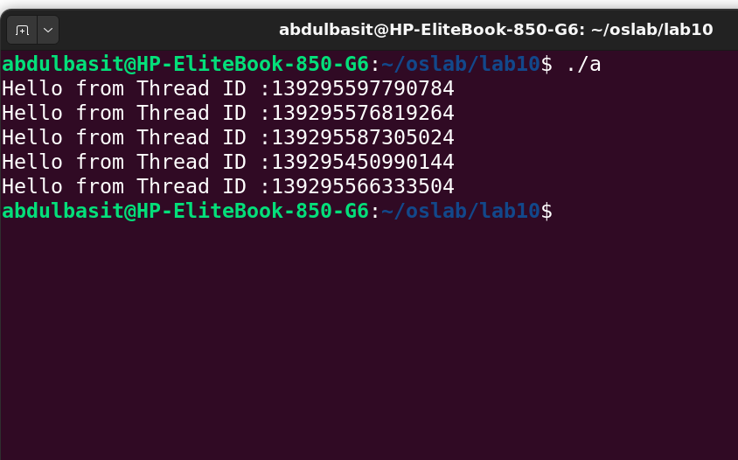
code:
#include <stdio.h>
#include <pthread.h>

void * func1(void * arg)
{
pthread_t t= pthread_self();
printf("Hello from Thread ID :%lu\n",t);
return NULL;
}
void * func2(void * arg)
{
pthread_t t= pthread_self();
printf("Hello from Thread ID :%lu\n",t);
return NULL;
}
void * func3(void * arg)
{
pthread_t t= pthread_self();
printf("Hello from Thread ID :%lu\n",t);
return NULL;
}
void * func4(void * arg)
{
pthread_t t= pthread_self();
printf("Hello from Thread ID :%lu\n",t);
return NULL;
}
void * func5(void * arg)
{
pthread_t t= pthread_self();
printf("Hello from Thread ID :%lu\n",t);
return NULL;
}

int main()
{
pthread_t t1;
pthread_create(&t1,NULL,func1,NULL);

pthread_t t2;
pthread_create(&t2,NULL,func1,NULL);

pthread_t t3;
pthread_create(&t3,NULL,func1,NULL);

pthread_t t4;
pthread_create(&t4,NULL,func1,NULL);

pthread_t t5;
pthread_create(&t5,NULL,func1,NULL);

pthread_join(t1,NULL);
pthread_join(t2,NULL);
pthread_join(t3,NULL);
pthread_join(t4,NULL);
pthread_join(t5,NULL);

return 0;
}

q2 and q3:
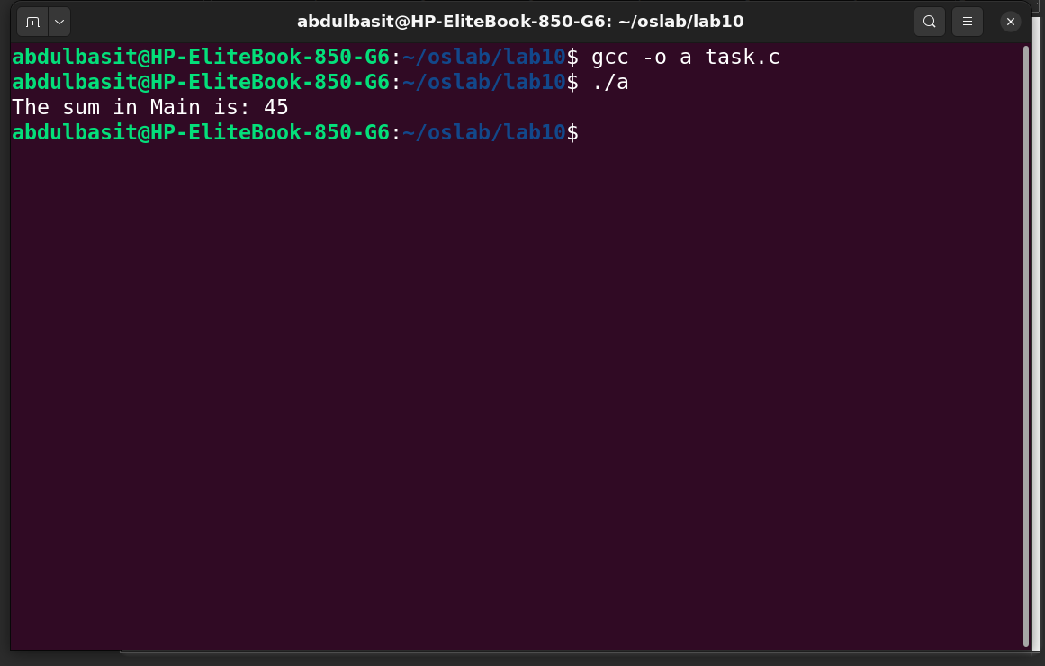
#include <stdio.h>
#include <stdlib.h>
#include <pthread.h>

struct array
{
int arr[10];
int size;
};

void *func1(void *arg)
{
struct array *temp = (struct array *)arg;
int sum = 0;

for (int i = 0; i < temp->size; i++)
{
sum += temp->arr[i];
}

int *sum2 = malloc(sizeof(int));
*sum2 = sum;
return sum2;
}

int main()
{
struct array a1;
a1.size = 10;
void *sum;

for (int i = 0; i < 10; i++)
{
a1.arr[i] = i;
}

pthread_t t1;
pthread_create(&t1, NULL, func1, &a1);
pthread_join(t1, &sum);

printf("The sum in Main is: %d\n", *(int *)sum);

free(sum);
return 0;
}

q4:
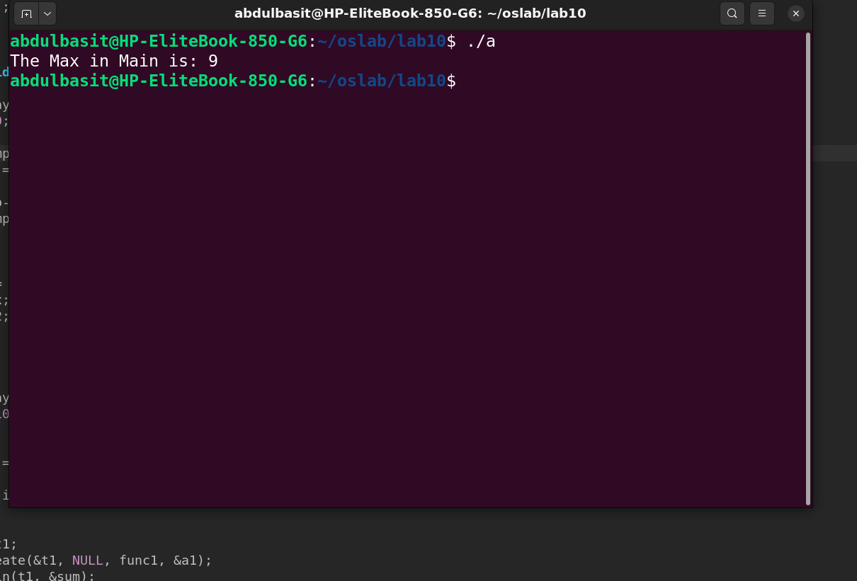
#include <stdio.h>
#include <stdlib.h>
#include <pthread.h>

struct array
{
int arr[10];
int size;
};

void *func1(void *arg)
{
struct array *temp = (struct array *)arg;
int max = 0;

max=temp->arr[0];
for (int i = 0; i < temp->size-1; i++)
{
if(temp->arr[i+1]>max)
max=temp->arr[i+1];

}

int *sum2 = malloc(sizeof(int));
*sum2 = max;
return sum2;
}

int main()
{
struct array a1;
a1.size = 10;
void *sum;

for (int i = 0; i < 10; i++)
{
a1.arr[i] = i;
}

pthread_t t1;
pthread_create(&t1, NULL, func1, &a1);
pthread_join(t1, &sum);

printf("The Max in Main is: %d\n", *(int *)sum);

free(sum);
return 0;
}

